**Design description:**

The design of the website has many elements that have been well thought through by the group and each of those elements has significance. The website consists of many web pages that are easily navigable. The breakdown of the major design decisions are as follows:

* Imagery plays a big part in our design. As the website is about cooking and baking, we want users to be attracted by strong visuals and bold colours. The main colour of the website is purple, and it’s meant to create a sense of harmony which we thought would attract users to spend more time on the website.
* A strong point of our design is the simplicity. The website is meant to be easy to navigate with a clear menu on the left-hand side, the menu consists of icons as well as short text description so the user understands what each web page contains.
* The menu is sticky, i.e. the user can always see it as they scroll down the page.

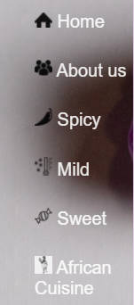

Diagram 1. Sticky menu

* Once the user is on a different web page (other than home), they have the option of either using the side sticky menu or clicking on the three bars on the top left hand corner that will bring them back to the previous page and, if there is none, to the home page.

 → 

Diagram 2. Three bars become an X once hovered over

* The main page is simple yet inviting using spaced-out sentences instead of a big chunk of text. There is a bit of humour introduced with a hungry and cute hamster. We have decided to include this image to invoke happy feelings in user’s brain when they visit the page.

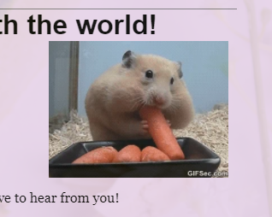

Diagram 3. Hungry hamster gif

The comment section underneath the text on the main page shows our interest in user’s feedback.

* About us page is divided into three pages so the information about each of us is showed clearly with contact information and the breakdown of work.
* The African cuisine and the sweet sections are also divided into 2-3 parts. We wanted at least one recipe to have a step-by-step process shown in a short slideshow (accordion) and this is shown in the Nutella bread recipe. This is also one of our Javascript elements.

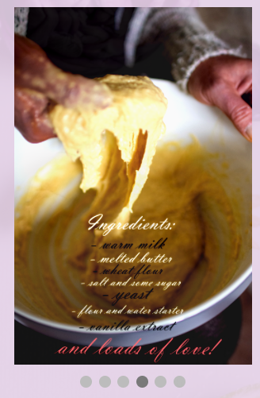

Diagram 4.Accordion recipe

* We have decided to make the webpages near transparent to showcase the background image. If the web pages consisted of text only, it would be hard for the user to focus on the content as the background image would be too distracting.
* We have decided it would be a good choice to have the background image consist of complimentary colours of purple and green.
* Most of the imagery on our website is done by us (including the logo) in order to create a sense of homeliness and we wanted to convince the users that we are genuine and honest.
* We have decided to link the social media of each of the students in the footer, so it is easy for the user to navigate and find the links (as these are present on every web page).

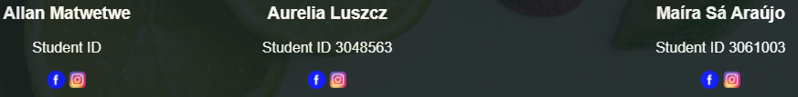

Diagram 5. Footer with student names, ID numbers and social media links.